Youth Fishing Derby
Sponsored by the Westfield Fish & Game Club
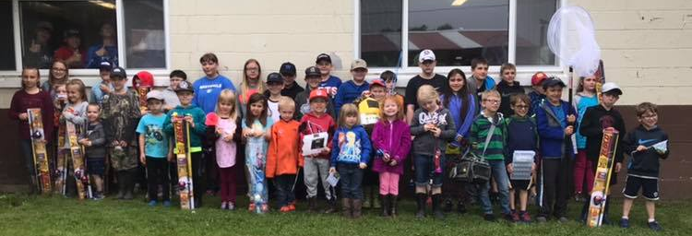
and the Westfield Rec. Dept.

All ages welcome to come to fish and have fun
Saturday, August 7th 2021 9:00am-2:00pm
@The Fish & Game Club *No Rain Date

Free Lunch Provided-feel free to bring your own lunch also.
Prizes divided into two age groups
4 yrs – 8 yrs & 9 yrs – 12 yrs
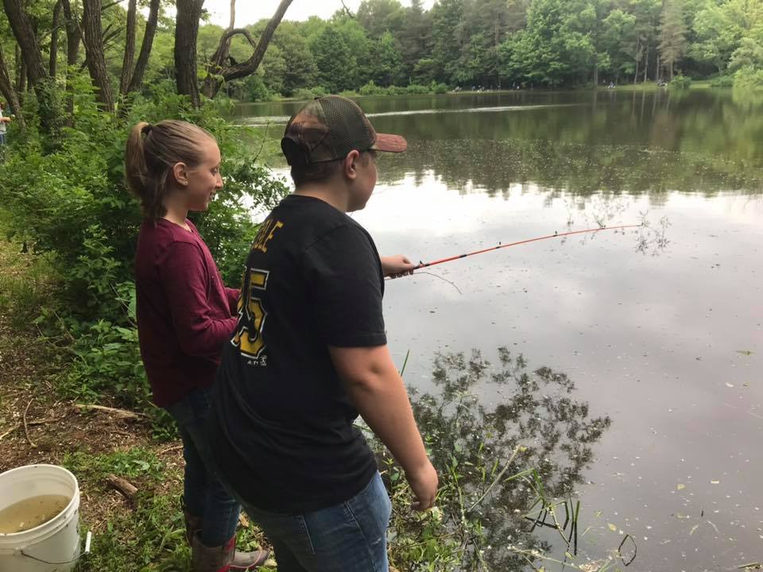
Bait is provided

